Williamson County
Veterans Treatment Court

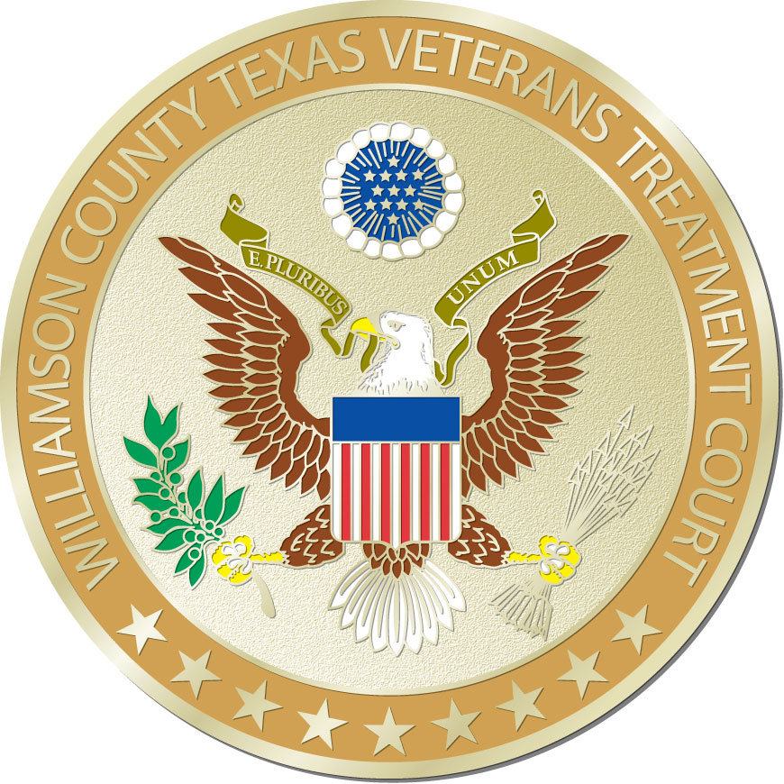

PARTICIPANT HANDBOOK

Revised January 2, 2019

TABLE OF CONTENTS

- Welcome to Veterans Treatment Court ………………………........................ Page 3 – 4
- Overview of Program ………………………………………………………………………….. Page 4 - 5
- Eligibility, Process and Program Length ……………………………………………….. Page 5
- Veterans Court Levels …………………………………………………………………………. Page 6 - 7
- Progress Self-Report …………………………………………………………………………… Page 8
- Level Promotion Request ……………………………………………………………………. Page 9
- Release of Information Form ………………………………………………………………. Page 10
- Bill of Rights ………………………………………………………………………………………… Page 11
- Veterans Court Progress Report …………………………………………………………… Page 12
- Graduation Request …………………………………………………………………………….. Page 13
- Mentor Program ………………………………………………………………………………….. Page 14

Welcome to the Williamson County Veterans Treatment Court Program
The Williamson County Veterans Treatment Court (“Court”) is designed to help you address some of the risk factors that have led to your involvement in the criminal justice system. The Court is offering you this opportunity because we believe that each Veteran in this Court has demonstrated commitment, courage and self-discipline in their role as a member of the United States military. We expect you will demonstrate these same characteristics in fulfilling the expectations of the Court.
We recognize that deployment to combat or other hazardous zones may make post-deployment life challenging. We also recognize there is often a correlation between such deployment and psychological issues that may manifest themselves in behavior that is out of character for those who served. Our goal is to assist you in addressing these issues so you can interrupt or avoid negative behaviors. Furthermore, it is our responsibility to ensure that you no longer pose a risk to the community, as well as to yourself. The way to achieve this is by helping you recognize and correct the thinking, behavior and other risk factors that have brought you in contact with the criminal justice system.
You will take part in the development of a Treatment Plan with your treatment provider of choice that will be designed to help identify the steps you will be expected to take as you address your risk factors. This may include, but not be limited to mental health counseling, substance abuse counseling and/or inpatient treatment. The Court will help you determine other goals that you may want to work on, including: education, employment, housing, and connection to your VA benefits, family counseling and social support. We recognize that change can be difficult. There are various stages we all go through as we attempt to develop healthier and, more productive patterns for ourselves. We will do whatever we can to help you recognize the benefit of change and support your efforts during this process as you work toward recovery and success in this program.
One of the ways the Veterans Treatment Court will support you is by providing you with a series of rewards (incentives) to reinforce your progress. Some incentives that you can expect during the Court program will be verbal praise, advancement through the levels in the Court, and reduction in the frequency of Court appearances. The Court may require you to wear an alcohol ankle monitor (SCRAM) or use an In-Home or Ignition Interlock Device for a period of time, as well as undergo random urinalysis. The Court, through your Case Manager will communicate closely with your treatment providers. It will be a condition for participation in the program that your information will be shared openly between treatment providers and the Court.
The Veterans Treatment Court will hold you accountable for failing to follow the expectations that you have agreed to meet and may assess you with sanctions. Sanctions may include, but are not be limited to, community service restitution hours, increased reporting to the Court, denial of promotion to the next level, etc. More serious violations could result in jail time and/or being expelled from the Veterans Treatment Court. It is important to realize that any sanctions that may be given are designed to help you correct behaviors that are considered high risk, to progress through the stages of change, and to successfully complete the Veterans Treatment Court Program. This Handbook includes an overview of the Program, the Participant Agreement, an explanation of the four levels, and progress reports you will need to complete for each of your Court appearances.
The entire Veterans Treatment Court team appreciates your military service and looks forward to helping you successfully complete your Veterans Treatment Court mission.
WILLIAMSON COUNTY VETERANS TREATMENT COURT
OVERVIEW
The Veterans Court Program utilizes a non-adversarial approach with a Project Team that includes: the Judge, Defense Attorney, Prosecutor, Program Coordinator, Case Manager, Mental Health Professionals, Mentor Coordinator, Veterans Service Officer and the Veterans Justice Outreach Specialist (VJO). The Project Team will work together with the Veteran to guide him/her toward successfully attaining their goals and completing the Court Program. The Court Program has two tracks available for Veterans who are charged with Class A or B Misdemeanors that may be related to Post Traumatic Stress Disorder (PTSD) or other mental health problems resulting from their military service. The two tracks available are the Pre-trial Diversion Track or the Probation Track. The Court Program may offer Veterans an opportunity to avoid prosecution and a criminal conviction if eligible for the Pre-Trial Diversion Track. The track will be determined by reviewing the nature of the arrest and the Veteran will be informed of the track available to them prior to their decision to participate in the Court.
Participants in the Court Program will be assessed for psychological, chemical dependency and other issues that can be addressed through various types of treatment and supportive services. The assessment of the Veteran will be done by the VA, or another licensed mental health treatment provider (Treatment Provider) of the Veterans choice. A list of Treatment Providers will be given to the Veteran. A Treatment Plan will be developed by the Treatment Provider and the Veteran after completion of the assessment. The Treatment Plan may be revised while the Veteran is enrolled in the Court Program, in order to meet the individualized needs of Veterans, as treatment progresses and information becomes available.
A Case Plan will also be created after the Veteran completes an evidenced-based Texas Risk Assessment with the Case Manager. The Case Plan will allow the Veteran input on individualized goals that they would like to achieve while entered into the Court Program. Some of these goals may include assisting the participating Veteran with obtaining employment, education, VA benefits, and health and housing services.
The Treatment and Case Plans (Plans) will be reviewed with the Veteran prior to pleading into the Court Program. After pleading into the Court, the Veteran will again review their Plans with their Case Manager prior to signing the Plans and beginning their Court Program. The Veteran will review the Plans with the Case Manager again after completion of Level 2 of the program.
The Project Team will work together with the Veteran to guide him/her toward successfully attaining their goals and completing the Court Program. Veterans will be provided with referrals for services needed to begin implementation of their Plans and will be scheduled for a series of Court appearances to monitor and reinforce their progress toward meeting the objectives of their Treatment and completion of the Phases in the Court Program. Once the objectives have been successfully met, the Veteran will graduate from the Program.
ELIGIBILITY CRITERIA FOR PARTICIPATION
To be eligible, a participant must be a Veteran or active member of the United States Armed Forces, including Reservists, National Guard or Coast Guard. Discharge from the military must be Honorable or General Under Honorable Conditions. Also, the Veteran must suffer from (whether diagnosed at the time of the offense or later) PTSD, Traumatic Brain Injury (TBI) mental illness, or a mental disorder that resulted from military service. Only Misdemeanor charges pending in Williamson County are currently eligible. Veterans must also reside in Williamson County or a contiguous county.
PROCESS
Applications for admission must be submitted to the County Attorney’s Office by the defense attorney representing the Veteran. Once an application is received, the prosecutor will screen the applicant for eligibility and determine the track which the Veteran will be allowed to pursue. The Court Coordinator will assist the Veteran in scheduling an assessment with the Veteran Justice Officer. If the Veteran meets the Program criteria and is accepted into the Program, their case will be transferred to the Veterans Court Defense Attorney.
PROGRAM LENGTH
The Veterans Court Program is minimally a 12 month Program that is broken up into four levels. The exact length of time in the Program is determined by each Participant’s needs, progress towards successful implementation of the Veteran’s Treatment and Plans, nature of the offense, and arrest history.

Williamson County Veterans Treatment Court Levels
Level One – Stabilization and Orientation (Minimum of 2 months)
Requirements
- Attend Veterans Treatment Court hearings the 1st and 3rd Thursday of each month, as scheduled.
- Attend appointments with your Case Manager every week.
- Enroll in and attend treatment according to the Individual Treatment Plan.
- Participate in peer support or self help as directed.
- Develop timeline to begin working on other goals as identified by the Veteran in the Texas Risk Assessment in the Case Plan.
- Comply with random urinalysis and maintain sobriety.
- The Veteran must maintain compliance with Court orders and be sanction free for a minimum of 10 days prior to promotion.
- Submit a Level Promotion Request (included in handbook) with Case Manager a minimum of 7 days prior to the Court date in which consideration for Level 2 is requested. Advancement to Level 2 will be dependent upon meeting the above expectations.

Level Two – Intensive Treatment (Minimum of 3 Months)
Requirements
- Attend Veterans Treatment Court hearings the 1st and 3rd Thursday of each month, as scheduled.
- Attend appointments with your Case Manager every 2nd and 4th week of the month.
- Continue attending treatment according to the Individual Treatment Plan. Primary treatment should be established during this level.
- Continue to work towards goals established in the Case Plan in accordance with timeline.
- Comply with random urinalysis and maintain sobriety.
- Establish pro-social relationships with people who are supportive of recovery.
- Obtain/maintain stable employment, that is conducive to a sober lifestyle and/or attend school, vocational training or volunteer, as directed.
- Maintain stable housing arrangements.
- The Veteran must maintain compliance with Court orders and be sanction free for a minimum of 20 days prior to promotion.
- Attend Self Help Recovery Groups as directed by Treatment Provider.
- Submit a Level Promotion Request with Case Manager a minimum of 7 days prior to the Court date in which consideration for Level 3 is requested. Advancement to Level 3 will be dependent upon meeting the above expectations.
___________________________________________________

Level Three – Recovery Skills Development (Minimum of 3 Months)
Requirements
- Attend Veterans Treatment Court Hearings on the 1st Thursday of every month, as scheduled.
- Attend appointments with your Case Manager monthly, as scheduled.
- Attend Community Transition or other treatment sessions as recommended by treatment provider.
- Meet with Case Manager and/or Project Team to review and reevaluate Individual Treatment Plan and goals.
- Continue to work toward goals established on the Case Plan according to the timeline.
- Evaluate finances and attend Financial Assistance, if necessary.
- Comply with random urinalysis and maintain sobriety.
- Maintain relationships with people who are supportive of positive goals.
- Maintain stable employment that is conducive to a sober life style, and/or attend school, vocational training or volunteer, as directed.
- Maintain stable housing arrangements.
- The Veteran must maintain compliance with Court orders and be sanction free for a minimum of 45 days prior to promotion.
- Attend Self Help Recovery Groups and work with your sponsor and/or mentor as directed
- Submit a Level Promotion Request with Case Manager a minimum of 7 days prior to the Court date in which consideration for Level 4 is requested. Advancement to Level 4 will be dependent upon meeting the above expectations.
____________________________________________________________________________________
Level Four – Community Transition with Evidence of Treatment
(Minimum of 4 Months)
- Attend Veterans Treatment Court hearings on the 1st Thursday of every month, as scheduled.
- Attend appointments with your Case Manager monthly, as scheduled.
- Complete and submit a Veterans Court Program Graduation Request Form a minimum of 30 days prior to the Court that the graduation is requested. A request for graduation should include a “Hello to My New Life” letter that can be read at graduation.
- Attend community transition or other treatment sessions as recommended by treatment provider.
- Continue to work toward goals established on the Case Plan according to the timeline.
- Create a personal action plan for continued success after program graduation. Action plan should include goals and identify ways that you would like to give back in the future to the Veteran community.
- Comply with random drug testing and maintain sobriety.
- Maintain stable employment that is conductive to a sober life style, and/or attend school, vocational training or volunteer, as directed.
- Maintain stable housing arrangements.
- The Veteran must maintain compliance with Court orders and be sanction free for a minimum of 90 days prior to Graduation.
- Attend Self Help Recovery Groups and work with your sponsor and/or mentor as directed
- Obtain Courts approval for Graduation from the Veterans Court Program.
- Invite friends and family to graduation when approved and scheduled.

Williamson County Veterans Treatment Court Progress Self-Report

Veteran: __________________________________________Court Date: ________________________
Branch of Service: __________________________________ Court Level: _______________________
Progress Since Last Court Appearance:
- Treatment Groups attended (dates): _________________________________________________

- Groups Missed (dates): _____________________________________________________________

- Support Groups attended (AA, Heroes Night Out, etc.): ___________________________________

- Reasons for Missing Groups: ________________________________________________________
Coping Skills Used:
- ________________________________________________________________________________
- ________________________________________________________________________________
- ________________________________________________________________________________
- ________________________________________________________________________________

Plan of Action before next Court Appearance:
- ________________________________________________________________________________
- ________________________________________________________________________________
- ________________________________________________________________________________

Other Comments or Concerns:

WILLIAMSON COUNTY VETERANS TREATMENT COURT
LEVEL PROMOTION REQUEST
Promotion to the next level is granted as recognition for compliance with the requirements you agreed to when accepted into the Veterans Court. These requirements are designed to help you meet the challenges of your post-service adjustment and to reduce your recidivism. Please explain to the Court what progress you feel you have made and why you should be promoted to the next level and what steps you intend to take to ensure that you maintain the positive status that you have demonstrated thus far:
_______________________________________________________________________________________________________________________________________________________________________________________________________________________________________________________________________________________________________________________________________________________________________________________________________________________________________________________________________________________________________________________________________________________________________________________________________________________________________________________________________________________________________________________________________________________________________________________________________________________________________________________________________________________________________________________________________________________________________________________________________________________________________________________________________________________________________________________________________________________________________________________________________________________________________________________________________________________________________________________________________________________________________________________________________________________________________________________________________________________________________________________________________________________________________________________________________________________________________________________________________________________________________________________________________________________________________________________________________________________________________________________________________________________________________________________________________________________________________________________________________________________________________________________________________________________________________________________.
(Add pages as necessary)

Name: _______________________________ Date: ______________

Release of Information

Williamson County Veterans Treatment Court Bill of Rights
- You have the right to accept or refuse participation after reading this explanation.
- If you agree to treatment, you have the right to change your mind at any time (unless specifically restricted by law). Of course, if you withdraw from the VTC, your case returns to normal prosecution channels.
- You have the right not to be discriminated against due to your race, creed, color, national origin, sex or physical disability.
- You have the right to a humane environment that provides reasonable protection from harm and appropriate privacy for your personal needs.
- You have the right to be free from abuse, neglect and exploitation.
- You have the right to be treated with dignity and respect.
- You have the right to appropriate treatment in the least restrictive setting available that meets your needs
- You have the right to be told about the VTC rules and regulations before you are admitted.
- You have the right to a Treatment Plan designed to meet your needs, and you have the right to take an active role in developing that plan.
- You have the right to meet with staff to review and update the Plan on a regular basis.
- You have the right to have information about you kept private and to be told about the times when the information can be released without your permission.
- You have the right to receive an explanation of your treatment and your rights if you have questions while you are in the VTC.
- You have the right to file a complaint and receive a fair response from the VTC within a reasonable amount of time.
- You have the right to receive a copy of these rights before you are admitted into the VTC, including the address and phone number of the Texas Department of Criminal Justice.
- You have the right to have your rights explained to you in simple terms, in a way you can understand, upon request.

If you feel that your rights have been violated or that you have been treated unfairly, you have the right to file a grievance with the Veterans Court Program Director, Steve Morrison, in writing (Williamson County CSCD, 301 S.E. Inner Loop, Suite 101, Georgetown, Texas 78626) or by phone (512-943-3500). You also have the right to complain directly to the Texas Department of Criminal Justice at any reasonable time in writing (209 W. 14th St, suite 400, Austin, TX 78701) or by phone (512-305-9300). You may also file a complaint with Kathy Blankenship, CSCD H.R. Representative, of the Williamson County CSCD Department in writing (301 S.E. Inner Loop, Suite 101, Georgetown, TX 78626) or by phone (512-943-3875).

Signature: _____________________ Date: _________________

VETERANS TREATMENT COURT
GRADUATION REQUEST
Graduation from the Veterans Court is granted as recognition for compliance with the requirements you agreed to when you were accepted into the Veterans Court. These requirements were designed to help you meet the challenges of your post-service adjustment and to reduce your risk of recidivism. Please explain to the Court what progress you feel you have made since entering the Veterans Court Program and why you believe you are ready to graduate. With reflection of your success, please write a “Hello to My New Life” letter that demonstrates the transition that you have achieved during the Court Program and describes the new life that you are about to embark upon.
_______________________________________________________________________________________________________________________________________________________________________________________________________________________________________________________________________________________________________________________________________________________________________________________________________________________________________________________________________________________________________________________________________________________________________________________________________________________________________________________________________________________________________________________________________________________________________________________________________________________________________________________________________________________________________________________________________________________________________________________________________________________________________________________________________________________________________________________________________________________________________________________________________________________________________________________________________________________________________________________________________________________________________________________________________________________________________________________________________________________________________________________________________________________________________________________________________________________________________________________________________________________________________________________________________________________________________________________________________________________________________________________________________________________________________________________________________________________________________________________________________________________________________________________________________________________________________________________.
(Add pages as necessary)

Name: _______________________________ Date: ______________

PEER MENTOR PROGRAM
You need to know that we have a unique support Program in the Veterans Treatment Court. It is the intent of this Court that all of our participating Veterans in this Program have a fellow Veteran that acts as a mentor, advocate, and ally.
This fellow Veteran will help you successfully readjust to civilian life, a life that has structure, hope and a future by providing ongoing support for you through all phases of the VTC.
Our Williamson County Veterans Treatment Court relies on cooperation and collaboration with the criminal justice system, the VA, Veteran’s service organizations, and community treatment agencies to provide comprehensive treatment for you. In addition to those agencies, we also rely on Peer Mentors. Peer Mentors are Veterans of the U.S. Armed Forces who volunteer their time for you. They provide advice, personal experiences, recommendations and guidance to Veterans like you. Peer Mentors include, but are not limited to, those who have served in Peacetime, Vietnam, Desert Storm/Shield, Operation Enduring Freedom, Operation Iraqi Freedom, and Afghanistan.
Your Peer Mentor Coordinator’s contact information:
Name: Jerry Sorsdal
E-Mail: jerry.sorsdal@gmail.com
Phone: 936-203-3254
Please feel free to contact Mr. Sorsdal with any questions, comments, or peer mentor referrals.
This is what your mentor does:
Mentors are veteran volunteers who are trained to assist you through the Veterans Treatment Court process. Your Peer Mentor acts as a coach, a guide, a role model, an advocate, and a support for you. He/she encourages, guides, and supports you as you progress through the Court supervised treatment program. This includes listening to your concerns and making general suggestions, assisting you in determining your needs, and supporting you in the quest for honest and straight forward answers. Your Mentor will not act as a counselor, but will instead assist you in identifying resources that might be helpful for your life circumstances and encourage you to get the help you need to solve your life’s challenges. The Mentors will support Veterans and “fill the gap” to help keep you moving successfully toward completing the Court Program. The mission of the Williamson County Mentors is to make certain to the best of their abilities to “Leave No Veteran Behind”.

